

SOME QUESTIONS ABOUT

YOUR KILN DRIER PROJECT

Company

Adress
- Fax
E-mail :
Person to contact :

1- TIMBER TO DRY OUT

Timber species and thicknesses to dry out monthly

Timber |  | thicknesses |  |  | Moisture |  | Length |  | m3/month
Species | % | wood | % | sticks | I | F | average | maxi | logs | edged

Are the species mixed ? yes no

Dimensions of a standard stack :

Do you have already a stacking system ?
Length : width : height :
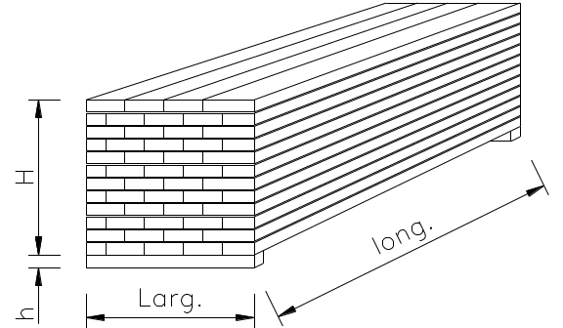
Including pallet :
Volume of a stack standard :_______m3

N° of ranks in height : _______

2- HANDLING

Do you want to load up by :
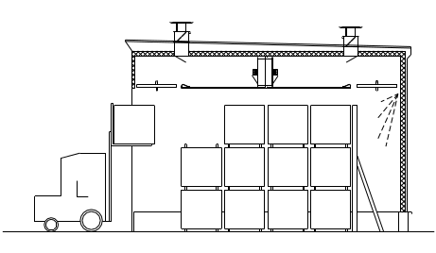
 lift truck

Mast height :

Type front side
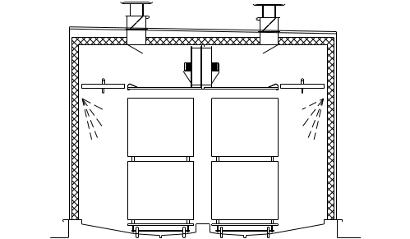

 railway carriage

Doors at both ends

Boggies to supply
How many pairs:_______
Rails to supply

 Moving kiln
2 berths multi-berths Number : ____

3- IS THERE ALREADY A KILN IN YOUR SITE ? Yes No

Capacity :______ Number : ______
Trademark : ______ Loading system : ___________________

How many stacks in length : _____ in width ____ in height____

Do you have trained staff for drying ? yes no

4- DO YOU HAVE A BOILER ? Yes No

Distance between driers and boiler ?
Installed power : __________ available : _________

5- HEATING

hot water - Temperature : ___/___ natural gas barks
thermic fluid - Temperature : ___/___ propane gas sawdust
steam - Pressure : ___/___ butane gas …
fuel oil
direct electricity (effet Joules)

Moisture Gas Thermal Transfert (gas direct burner)

6- PROPOSAL REQUESTED

Number of kilns :______ average capacity desired :_____
Number of kilns :______ average capacity desired :_____
Number of kilns :______ average capacity desired :_____
joined side by side separated
in the open air under existing facilities
In the second case, what is the inner height ?
Construction :
all aluminium masonry built combined (masonry walls /
aluminium roof and doors)

Do you wish a technical room ? yes no
Control system semi-automatic by computer

7- SCHEME

Please draw a sketch of the desired layout and the place, giving full details

8- When is this project scheduled for ?





